BATCH ID: B10-4A6E

ROLL NO: SREC1902003

NAME: AHILA A

CODE:

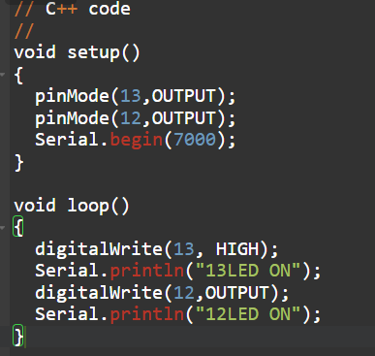

SIMULATION:

